**UNIVERSITY OF GREENWICH**  
COMP1682–   
Final Year Project

COURSEWORK

|  |  |
| --- | --- |
| Student name | PHAM HUU NGHIA |
| ID number (00xxxxxxx) | 001272795 |
| Lecturer/Tutor name | NGUYEN THAI NGHE |
| Student submission date | November 25th, 2022(chưa biết ) |

COMP1682 Final Report

**Project Name: Developing an online fast-food e-commerce system.**

**Pham Huu Nghia 001272795**

**Supervisor: NGUYEN THAI NGHE**

**Final Year Report**

**COMP1682 Final Year Project**

**Program Title: BSc Hons Computing**

**Word count: 10.000 (Minimum)**

**Abstract**

Project Name: **Developing an online fast-food e-commerce system.**

The purpose of this report is to provide a comprehensive overview of fast-food e-commerce systems, including their definition, explanation, and analysis. The report aims to inform readers about the role of e-commerce in the fast-food industry and discuss the process of building an e-commerce website. The report includes documented reviews of the technology used to build the websites. Additionally, the report covers the product design and testing phases, which are crucial in ensuring a high-quality result. Finally, the report concludes with a critical review of the e-commerce product, highlighting its strengths and potential areas for improvement.

**Acknowledgements**

I would like to express my deepest appreciation to all those who provided me the possibility to complete this report. A special gratitude I give to our final year project manager, [Mr Nghe], whose contribution in stimulating suggestions and encouragement, helped me to coordinate my project especially in writing this report.

Furthermore, I would also like to acknowledge with much appreciation the crucial role of the staff of [Mr Nghe], who gave the permission to use all required equipment and the necessary materials to complete the task “**Developing an online fast-food e-commerce system**”. A special thanks goes to my teammate, [Mr Nghe], who help me to assemble the parts and gave suggestion about the task “**Developing an online fast-food e-commerce system**”. Last but not least, many thanks go to the head of the project, [Ms/Mr/Dr Surname] whose have invested his full effort in guiding the team in achieving the goal. I have to appreciate the guidance given by other supervisor as well as the panels especially in our project presentation that has improved our presentation skills thanks to their comment and advice.

Table of contents

1. Introduction 6

1.1 Background 6

1.2 Aim 6

2. Objectives 7

3. Approach 8

3.1 Justification of the suitability of a Methodology or a Framework followed. 8

4. Literature Review 9

4.1 Approach to literature searching 9

4.2 Technology A 9

4.3 Technology B 9

4.4 Technology C 9

4.5 Market analysis 9

5. Legal, Social, Ethical and Professional Issues and Considerations 10

6. Requirements 11

6.1 Analysis of requirements 11

6.2 Existing Solutions 11

6.2.1 Product A 11

6.2.2 Product B 11

6.2.3 Product C 11

6.2.4 Conclusion 11

7. Business Requirements 12

7.1 Overall Picture 12

7.2 Functional Requirements with MoSCoW prioritisation 12

7.3 Non-functional Requirements 12

8. Analysis and Design 13

8.1 Architecture 13

8.2 High Level Design 13

8.2.1 Assumptions 13

8.2.2 Overall 13

8.2.3 Endpoints 13

8.2.4 3rd party Services 13

8.3 Technology choices 13

8.3.1 Front End 13

8.3.2 Back End 13

8.3.3 Mobile App 13

8.4 Use case Diagram 13

8.4.1 Primary and Secondary Use-case scenario 13

8.5 Entity Relationship Diagrams 13

8.5.1 Physical design (Capacity) 13

8.6 Wireframes for prototypes 13

8.7 Class Diagram 13

8.8 Activity Diagram / Sequence Diagram 13

9. Implementation 14

9.1 Database 14

9.2 Front End 14

9.3 Back End 14

9.4 Deployment 14

9.5 Images 14

10. Testing 15

11. Evaluation 16

11.1 Summarised Key findings from the project 16

11.2 Recommendations for future development 16

11.3 Project Evaluation 16

11.4 Personal Evaluation 16

11.5 Conclusion 16

11.5.1 What went well? 16

11.5.2 What did not go well? 16

11.5.3 What have I learned from this project? 16

11.5.4 Future development 16

12. References 17

13. Appendix A – Project Proposal 18

14. Appendix B 19

15. Appendix C 20

# Introduction

## Background

E-commerce has become a fundamental part of our daily lives, as it offers convenience, accessibility, and affordability. It has revolutionized how we shop, transforming traditional brick-and-mortar stores into virtual marketplaces that can be accessed from anywhere in the world. In recent years, there has been a surge in e-commerce activity, with more businesses and consumers embracing this digital platform.

One of the main reasons for the popularity of e-commerce is the ease and convenience it offers. With just a few clicks, consumers can order products from the comfort of their own homes, and businesses can reach a global audience without the need for physical storefronts. E-commerce has also helped to eliminate geographical barriers, allowing consumers to purchase products from anywhere in the world, and businesses to expand their customer base beyond their local markets.

Another trend that has emerged in recent years is the use of mobile devices for e-commerce transactions. With the proliferation of smartphones and tablets, consumers can now shop online while on the go, making e-commerce even more accessible and convenient. Mobile apps have become increasingly popular for e-commerce, providing consumers with a seamless shopping experience, and enabling businesses to reach their target audiences more effectively.

In addition to the convenience factor, e-commerce has also created new business opportunities, particularly for small and medium-sized enterprises (SMEs). With low startup costs and minimal overheads, SMEs can now compete with larger businesses on a global scale and reach a wider audience through e-commerce platforms.

In this context, the fast-food industry is also embracing e-commerce, with many fast-food chains now offering online ordering and delivery services. This has enabled consumers to order food from their favourite fast-food chains without leaving their homes and has also increased the efficiency of the ordering process during peak hours or inclement weather.

My e-commerce project is a Fast-Food website that gives users the ability to order food online, especially during busy times or adverse weather conditions. The platform offers a wide range of functions that ensure a seamless and secure ordering experience for customers.

## Aim

This project aims to develop an online fast food e-commerce system.

# Objectives

## Research

* + - Find e-commerce related material and selected topic. Citations from reliable sources (books, articles, reputable references).
    - Research some technologies that can be used for existing e-commerce systems on the market.
    - Study the system to suggest, analyse and evaluate the benefits it brings to the system.
    - Research legal, social, ethical, and professional issues with the project.
    - Planning and implementing data collection.
    - Take a survey through Google Forms

## Analysis

* + - Analyse system requirements.
    - Analyse user needs.
    - Analyse the functional requirements.
    - Analyse non-functional requirements.
    - Analyse system functions

## Design & Implementation

* + - Design the site map of the system.
    - Database design and coding.
    - Design the user interface (UI) for the main functions of the system.
    - Create a cloud-based website.
    - Deploy the database to the system.
    - Design Registration function linked with UI and Database.
    - Design the Sign-in function associated with the User Interface and the Database.
    - Design function View and Update records related to UI and Database.
    - Design the Product Management function in association with User Interface and Database with Create, Read, Update, Delete (CRUD) functions.
    - Design function Shopping Cart with UI and Database with Update and Delete function.
    - Functional Design View product details with user interface and database.
    - Design the Search function associated with the User Interface and the Database.
    - Design the Order functionality associated with the User Interface and Database.
    - Design the Order Management function linked with UI and Database.

## Test

* + - Test Database
    - Test all system functions.
    - Test connecting the system to the database in the cloud.
    - Test the application running on different devices.

## Evaluation and conclusions

* + - Overview of the e-commerce system.
    - Evaluate the strengths and weaknesses of the system.
    - Personal rating
    - Write a conclusion for the project.
    - Evaluate the future development of the system.

# Approach

For my current project, I have decided to use the Waterfall model as the Software Development Life Cycle (SDLC) methodology. This approach is considered one of the simplest project management models available, and it follows a sequential and linear design process. Although the popularity of the Waterfall model has decreased in recent years, as more agile methodologies have emerged, it is still a suitable choice for this project's objectives. The key to success with this model is to adhere to the outlined steps and ensure that each stage is completed before moving on to the next.

The Waterfall model is particularly well-suited for small-scale and short-term projects, such as this personal project. Its straightforward design makes it easy to understand and implement, and it ensures that each stage is completed thoroughly and with care. Additionally, the Waterfall model is cost-effective and efficient, making it a practical option for personal projects with limited resources.

While other methodologies may offer more flexibility or adaptability, the Waterfall model provides a clear structure and process that can be beneficial for specific projects. Overall, I believe that the Waterfall model is the best fit for my current project's goals and requirements.

## Justification of the suitability of a Methodology or a Framework followed.

The chosen SDLC model for this project is the waterfall model, which is a sequential and linear methodology in software development. The project will undergo several stages, beginning with the requirement gathering stage where we will identify the project's objectives, goals, and constraints. This will be followed by the design phase, where we will create the system's logic, functions, and shape, ensuring that it meets the requirements identified in the previous stage.

After completing the design phase, we will move to the implementation phase, where the system will be constructed according to the design. The testing phase will follow to check if the implemented functions are working correctly and if the system design goals are met. If the testing is successful, the project will then move to the deployment phase where it will be made available to users. The final phase is the maintenance phase, where the project's performance is monitored, and updates are made based on customer feedback.

By following the above stages, we aim to deliver a fully functional system within a few months. This will allow us to start realizing the benefits of the system quickly and assess its capabilities. Though the waterfall model is considered old-fashioned, it is still a useful approach in small-scale and short-term projects, and it is ideal for personal projects like this one.

# Literature Review

## Approach to literature searching.

To carry out this research, the initial step is to ensure that all the gathered information is thoroughly scrutinized and cited by a diverse range of scholars. The research will center on e-commerce and the technologies employed in building an e-commerce system, which will be examined by analysing relevant books and articles. The data has been gathered from various databases, including Google Scholar, ResearchGate, and other repositories featuring articles and books related to the subject matter.

## Identifying the problem

According to the article "Online food delivery: A systematic synthesis of literature and a framework development" provides a comprehensive overview of the current state of online food delivery systems. The authors conducted a thorough review of relevant academic literature and identified key factors influencing the success of online food delivery platforms, such as customer trust, service quality, and website usability.

The article also presents a new framework for analysing and evaluating online food delivery systems. The framework is based on four key dimensions: customer, service provider, technology, and environment. Within each dimension, specific factors are identified and explained in detail.

One strength of this article is its thoroughness in reviewing the literature and identifying key factors and dimensions. The framework presented in the article is a valuable tool for researchers and practitioners in the field of online food delivery systems.

However, one potential weakness of the article is its limited focus on literature published between 2010 and 2019, which may not fully capture recent developments in the field. Additionally, while the framework provides a useful structure for analysis, it may not account for all possible factors and dimensions that can impact the success of an online food delivery system.

Overall, this article is a valuable contribution to the field of online food delivery systems and provides useful insights for researchers and practitioners alike.(Shankar *et al.*, 2022)

## E-commerce and projects

According to the book " **Introduction to E-Commerce** " by Kenneth C. Laudon and Carol Guercio Traver edited by Zheng Qin is a comprehensive guide that explores the fast-paced world of e-commerce. It delves into the technological advancements that have revolutionized the way businesses conduct their operations and how they interact with their customers. The authors provide a thorough analysis of the different business models, marketing strategies, and legal issues surrounding e-commerce.

One of the strengths of this book is its ability to cover a wide range of topics, from the history of e-commerce to the latest trends and future predictions. It provides numerous real-world examples and case studies to help readers understand the concepts and apply them in practical scenarios. The book is well-structured, with each chapter building on the previous one, making it easy for readers to follow and retain the information.

Moreover, the book is written in clear and concise language, making it accessible to both business professionals and students. The authors also use various visual aids such as tables, diagrams, and graphs to explain complex concepts in a simplified manner.

Overall, "E-commerce: Business, Technology, Society" is an excellent resource for anyone interested in learning about e-commerce. It provides a comprehensive and in-depth analysis of the field, covering all aspects of the industry. Whether you are a business owner, a marketer, or a student, this book is an invaluable tool that can help you navigate the complex world of e-commerce.(C. Laudon and Traver, 2010)

The article "**Trends in e-commerce for the food marketing system**" provides an overview of the current trends and future possibilities of e-commerce in the food industry. The authors identify several factors contributing to the growth of e-commerce in the food sector, including changing consumer behavior, technological advancements, and the rise of mobile devices. The article also discusses different types of e-commerce models such as business-to-business (B2B) and business-to-consumer (B2C) and how these models are transforming the food industry's supply chain and logistics.

Moreover, the article highlights the significance of the "last-mile delivery" concept and how it has become a crucial factor for companies to succeed in e-commerce. The authors also discuss how companies can utilize data analytics and machine learning to improve their e-commerce operations and personalize their offerings to meet consumer demands. Additionally, the article identifies some of the challenges that e-commerce companies may face in the food industry, such as maintaining food safety standards, maintaining customer loyalty, and managing returns and refunds.

Overall, this article provides valuable insights into the growing importance of e-commerce in the food industry and highlights the opportunities and challenges associated with this trend. The article is a useful resource for researchers, policymakers, and professionals in the food industry who want to keep up with the latest developments in e-commerce and explore its potential for their businesses.(Carpio and Lange, 2015)

The article titled "**Factors Affecting Customers’ Perceptions and Firms’ Decisions Concerning Online Fast-Food Ordering**" presents a study on the factors that influence customers' perceptions of online fast food ordering and the corresponding decisions of firms operating in this industry. The research is conducted through a survey of 205 participants, who are asked to evaluate different attributes of online ordering platforms.

The authors find that customers' perceptions of online fast-food ordering are influenced by various factors, such as the ease of use, reliability, responsiveness, and security of the platform. In addition, the study shows that firms' decisions to adopt online ordering platforms are influenced by factors such as the costs and benefits of implementation, the level of competition in the industry, and the potential impact on the overall customer experience.

Overall, the article provides valuable insights into the complex interplay between customers' perceptions and firms' decisions in the context of online fast-food ordering. The study's findings can be useful for firms looking to optimize their online ordering platforms and improve the overall customer experience, as well as for researchers interested in understanding the factors that drive the adoption of new technologies in the food industry. However, it should be noted that the study has certain limitations, such as the relatively small sample size and the focus on a specific geographic region, which may limit the generalizability of the findings.(Papaioannou *et al.*, 2015)

## E-commerce development

"**Programming PHP**" by Kevin Tatroe, Peter MacIntyre, and Rasmus Lerdorf is a comprehensive guide to the PHP programming language. The book covers a wide range of topics, from the basics of PHP syntax and data types to more advanced concepts such as object-oriented programming and web application development.

One of the strengths of this book is its clear and concise writing style. The authors explain complex concepts in a way that is easy to understand and follow, even for readers with no prior programming experience. Additionally, the book provides plenty of code examples and practical exercises to help readers apply what they've learned.

The book is also up to date with the latest version of PHP at the time of its publication, version 7. The authors cover new features such as scalar type hints and return type declarations, as well as best practices for writing secure and efficient PHP code.

Overall, "Programming PHP" is an excellent resource for anyone looking to learn or improve their PHP programming skills. It is well-organized, easy to read, and packed with practical information and examples.(Lerdorf et al., 2002)

"**JavaScript Design Patterns**" by Addy Osmani is an excellent resource for any JavaScript developer looking to improve their code quality and structure. The book covers a wide range of design patterns, from the classic Gang of Four patterns to modern patterns specific to JavaScript development.

One of the strengths of this book is the clear and concise way in which the author explains each pattern. The examples provided are also practical and relevant to real-world scenarios, making it easy for readers to apply the patterns to their own code.

Another strength of the book is the focus on best practices and optimization. The author provides tips on how to write efficient and scalable code, as well as how to avoid common pitfalls and anti-patterns.

Overall, "**JavaScript Design Patterns**" is a valuable resource for any JavaScript developer looking to improve their skills and write better code. The book is well-written, well-organized, and packed with practical information and examples.(Osmani, 2012)

"**Guide to Software Development: Designing and Managing the Life Cycle**" by Arthur M. Langer is a comprehensive guide to software development, covering everything from design and planning to testing and maintenance. The book is aimed at both students and professionals, and it is designed to provide a broad overview of the software development process.

One of the strengths of this book is the author's emphasis on practical considerations. The author provides detailed guidance on project management, risk assessment, and team organization, as well as tips on how to manage client relationships and communicate effectively with stakeholders.

Another strength of the book is the clear and accessible writing style. The author presents complex concepts in a way that is easy to understand, even for readers with no prior experience in software development.

Overall, this book is a valuable resource for anyone involved in software development, whether students, professionals, or managers. The book is well organized, comprehensive, and packed with information and practical examples. If you are looking to improve your understanding of the software development process, then this book is definitely worth reading.(Langer, 2012)

"**Learning Heroku Postgres**" by Patrick Espake is an excellent resource for anyone looking to learn how to use Heroku Postgres for their database needs. The book is well-written and easy to follow, making it accessible to readers with a range of technical backgrounds.

One of the strengths of this book is the author's focus on practical examples. The book is filled with step-by-step instructions and real-world scenarios that allow readers to learn by doing. This approach is particularly helpful for those who are new to Heroku Postgres or who are looking to expand their knowledge of the platform.

Another strength of the book is the author's coverage of advanced topics. The book goes beyond the basics of Heroku Postgres and covers advanced topics such as replication, backups, and security. This makes the book a valuable resource for experienced database administrators as well as those who are just starting out.

Overall, "Learning Heroku Postgres" is a great resource for anyone looking to learn how to use Heroku Postgres for their database needs. The book is well-organized, thorough, and filled with practical information and examples. (Espake, 2015)

The article "**Database Design for Real-World E-Commerce Systems**" by Il-Yeol Song, Kyu-Young Whang, and Taejeon Korea is a comprehensive and informative resource for anyone interested in designing database systems for e-commerce applications. The authors present a detailed overview of various design aspects, such as data modeling, normalization, indexing, and database administration, among others.

One of the strengths of the article is its focus on real-world examples. The authors use case studies and practical examples to illustrate how database design can be applied to solve real-world problems in e-commerce systems. This approach makes the article more accessible and practical for readers with a range of technical backgrounds.

Another strength of the article is the authors' emphasis on scalability and performance. The authors provide insights into how database design can impact the performance of e-commerce systems and offer tips and best practices to optimize database performance.

Overall, "**Database Design for Real-World E-Commerce Systems**" is a valuable resource for anyone involved in designing, implementing, or maintaining database systems for e-commerce applications. The article is well-organized, comprehensive, and filled with practical examples and insights. If you are interested in gaining a deeper understanding of e-commerce database design, this article is definitely worth reading.(Song, Whang and Korea, 2000)

## Suggestion system

The article "Recommender Systems in E-Commerce" by Sanjeevan Sivapalan, Alireza Sadeghian, Asad M. Madni, and Hossein Rahanam is a well-written and informative review of recommender systems and their role in e-commerce.

The authors begin by providing an overview of e-commerce and the challenges that it poses to businesses, including the need to effectively recommend products to customers. They then delve into the different types of recommender systems, including content-based, collaborative filtering, and hybrid approaches.

The article also discusses various techniques and algorithms used in recommender systems, such as matrix factorization, neighborhood-based methods, and deep learning. Additionally, the authors explore some of the challenges and limitations of recommender systems, such as the cold start problem and the issue of data sparsity.

Overall, "Recommender Systems in E-Commerce" is a valuable resource for anyone interested in understanding the role of recommender systems in e-commerce and the techniques and algorithms used to implement them. The authors provide clear explanations and examples throughout the article, making it accessible to readers with different levels of expertise in the field.(Sivapalan *et al.*, 2014)

# Legal, Social, Ethical and Professional Issues and Considerations

Legal Issues: Presence technologies raise legal concerns, such as privacy, intellectual property, and liability for harm caused by virtual environments. There is a need for a clear legal framework to regulate the use of these technologies and to ensure the protection of user rights.

Social Issues: Presence technologies have the potential to affect social interactions, including changing the way people communicate and interact with each other. It is important to consider the broader social implications of these technologies and to engage in a dialogue with stakeholders to ensure that the potential benefits are maximized, and the potential risks are mitigated.

Ethical Issues: Presence technologies can raise ethical concerns, such as the potential for addiction, deception, and manipulation of users. Researchers and developers need to adhere to ethical standards and consider the potential consequences of their work.

Professional Issues: Researchers and developers in the presence field need to adhere to professional standards and best practices, such as obtaining informed consent from users, ensuring the protection of user privacy, and avoiding harm to users. It is important to establish a culture of professionalism in the presence field to ensure the responsible development and use of these technologies. (Schroeder, Meyer and Ziewitz, 2009)

# Requirements

Requirements are essential to understand the tasks that need to be performed to successfully complete a project. They ensure that all stakeholders involved in the project comprehend what is required to meet the client's expectations. It is vital to initiate a project by conducting a requirement analysis as it enables stakeholders to communicate their issues with the current system and what they expect the new system to accomplish. Understanding the customer's problems is the key to identifying the necessary elements for the new system. However, there are various types of requirements that support different aspects of the project, such as functional, non-functional, and business requirements, among others. To start with, it is crucial to determine all requirements for the project. This allows for a clear understanding of the project's scope and helps ensure that all necessary components are considered before moving forward with the project. A thorough requirement analysis sets the foundation for a successful project by identifying what needs to be achieved and how it can be accomplished.

## Analysis of requirements

In this project, there were no third-party stakeholders to survey or question. As a result, the developer had to rely on other methods to establish the requirements for the system.

The primary approach was to engage in discussions with the clients to better understand their needs and preferences. This involved gathering information on the functional requirements, as well as any constraints or limitations that needed to be taken into account. Additionally, the developer conducted research on existing competitor systems to identify potential areas for improvement and features that could be added to enhance the program.

While the lack of third-party stakeholder input presented a challenge, the developer established the requirements for the system through a combination of client engagement and market research. The resulting system met the needs of the clients and included features that set it apart from other systems in the marketplace.

## Existing Solutions

### KFC

KFC is a global fast-food chain known for its delicious fried chicken. It was founded in 1952 by Colonel Harland Sanders in Corbin, Kentucky, USA. Today, KFC operates in 145 countries and territories with over 27,000 restaurants serving around 12 million customers daily. In Vietnam, KFC opened its first restaurant in Ho Chi Minh City in 1997 and has since expanded to over 172 locations across 39 provinces.[1]

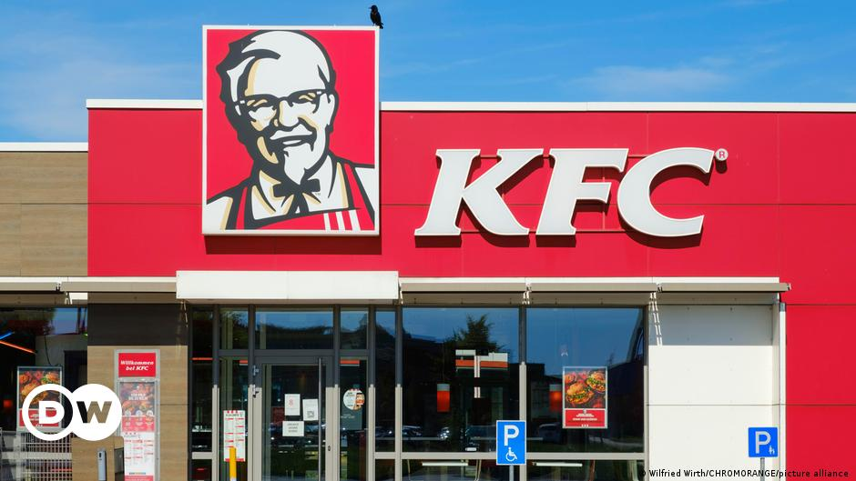

Figure 1 KFC[2]

KFC is one of the leading fast-food brands globally, with many notable advantages. First, KFC offers a wide range of delicious dishes, including fried chicken, burgers, sandwiches, shrimp cheese and fries. Customers can choose according to their taste and needs.

Second, KFC is present in almost every country in the world, and also provides many options for customers to easily reach, including online and door-to-door delivery.

Third, KFC is a reputable fast-food brand, with more than 27,000 restaurants globally and more than 12 million customers every day. KFC has always focused on ensuring product quality and the best possible customer experience.

However, the downside of KFC is that some of their products are high in fat and sugar, which is harmful to health if consumed in excess. Moreover, menu is mainly focused on chicken dishes and KFC's prices are not the cheapest in the industry, leading some customers to look for other fast-food options with more affordable prices.

### Macdonald

McDonald's is a popular fast-food restaurant chain known for its affordable and quick meals, such as burgers, fries, and shakes. The company has expanded to over 100 countries, with over 38,000 restaurants worldwide serving millions of customers every day. McDonald's has also introduced healthier options to its menu in recent years. However, the company has faced criticism for its impact on public health and the environment, including accusations of contributing to the obesity epidemic and environmental problems. Despite these challenges, McDonald's remains a dominant player in the fast-food industry, with a loyal customer base and a reputation for convenience and affordability.[3]



Figure 2 McDonald's[4]

McDonald's is one of the most recognizable fast food restaurant chains in the world. One of McDonald's biggest advantages is convenience - with thousands of locations worldwide, it's easy to find a McDonald's restaurant no matter where you are. The company is also known for its affordable prices, making it an attractive option for consumers on a tight budget. In addition to traditional menu items such as burgers and fries, McDonald's has also introduced healthier options to meet changing consumer tastes. Compared to KFC, McDonalds’ menu is also more diverse.

Like KFC, McDonald's also faces public health issues. Many items on the McDonald's menu are high in calories, fat, and sodium, contributing to the global obesity epidemic. In addition, the company has been accused of unethical practices such as marketing to children and contributing to environmental problems. Despite these challenges, McDonald's remains a popular choice among fast food consumers worldwide thanks to its convenience, affordability, and recognizable brand.

### Conclusion

The success of products like KFC and McDonald's highlights the immense popularity of fast-food chains. As technology has evolved, many of these restaurants have also embraced online e-commerce systems to cater to the changing needs of consumers. This has led to the rise of online fast-food e-commerce systems, which offer a convenient and efficient way for customers to order and receive their favourite meals.

In recent years, the demand for online fast-food e-commerce systems has grown significantly, driven by factors such as increasing internet and smartphone usage, changing consumer preferences, and the convenience of home delivery. With the COVID-19 pandemic accelerating the shift towards online ordering and home delivery, the demand for these systems is expected to continue to rise.

# Business Requirements

## Overall Picture

## Functional Requirements with MoSCoW prioritisation

Table 1 Functional requirements with MoSCoW prioritisation

|  |  |  |  |
| --- | --- | --- | --- |
| No | Functional requirements | MoSCoW | Justification |
| 1 | Online ordering system with the ability to customize orders and select delivery or pickup options. | Must Have | This is a 'must have' as the focus of the final system is on creating a fast-food e-commerce website so that customers can order food home. Without this function, the system will be useless |
| 2 | Payment gateway integration for secure and convenient online payments. | Must Have | This is a 'must have' because the system will order online so obviously there must be an online payment function |
| 3 | Order tracking system to monitor the status of orders and provide estimated delivery times. | Must Have | This is a 'must have' because without this function users will not know when their order will be delivered. |
| 4 | User-friendly interface with easy navigation and intuitive design. | Must Have | This is a 'must have' as the look and feel is an important part of a website. If the interface is not user-friendly, it will be difficult for users to use, leading to consequences such as not being able to place an order or not wanting to use the website. |
| 5 | Mobile optimization for easy access and ordering on mobile devices. | Should Have | This is a 'must have' because not everyone has time to turn on their computers to place an order |
|  | Integration with third-party delivery services for expanded delivery options. | Should Have | This is a 'should have' as it will be faster to hire more staff to deliver. |
|  | Nutritional information for menu items to cater to health-conscious customers. | Could Have | This is a 'could have' thing because it gives the user an overview of the food |
|  | Order history and saved preferences for faster checkout and personalized experiences. | Could Have | This is a 'could have' thing because it will make users faster when using the website |
|  | Personalized recommendations and promotions based on order history and preferences. | Could Have | This is a 'probable' thing because it will help users choose dishes faster |

## Non-functional Requirements

* The website should be stable and not hang or slow down during use.
* The page load time should be fast so that users don't have to wait long.
* The website must have security measures in place to secure user information and avoid user attacks.
* The website must be compatible with many different types of browsers and must be accessible on many different devices.
* The website must be always available for use and not be interrupted by system failures.
* The website must be able to adapt to the latest changes and updates.
* The website must meet the proprietary standards of the organization or business.

# Analysis and Design

## Architecture

## Site map

### User

Figure 3 site map user

* **Explain**:

A site map provides an overview of the structure of a website for users. It helps users to understand the hierarchy of the pages and how they are interconnected. Typically, a site map displays the pages of the website in a hierarchical fashion, with the homepage at the top and subsequent pages branching out below it.

For instance, a site map may begin with the homepage and branch out to pages such as "Sign-in," "Profile," and "Cart Confirmation." One-way arrows on the site map represent the direction of movement, such as moving from "Sign In" to "Sign Up" but not vice versa.

### Admin

Figure 4 site map admin

* **Explain**:

The admin sitemap does not start with the home page but begins with the Sign in page for users. After logging in with the admin account, the admin can access their home page. From there, the admin can navigate to pages such as Manage Product, Category, Customer, and Order. From each of these pages, they can then access the Create, Read, Update, Delete (CRUD) pages for their respective entities. However, the Manage Customer page only allows deleting a customer, while the Manage Order page only allows viewing order details and deleting an order.

## Technology choices

### Front End

The front-end of a website plays a crucial role in the user experience and overall success of the site. This website is built using HTML, CSS, and JavaScript - all popular front-end web development technologies.

Figure 5 Front-end [5]

HTML, or Hypertext Markup Language, is used to structure and organize the content of the website. It defines the elements of the website such as headings, paragraphs, links, and images, which provide the structure and semantic meaning to the website content.

CSS, or Cascading Style Sheets, is used to style the website and provide a visual presentation to the users. It is responsible for the design and layout of the website, including fonts, colors, and positioning of various elements on the page.

JavaScript, a programming language, is used to add interactivity and functionality to the website. It is responsible for making the website more dynamic and engaging for the users, allowing for things such as form validation and interactive user interfaces.

### Back End

PHP and MySQL are two popular technologies that are commonly used in web development. PHP is a server-side scripting language that is used to create dynamic web pages, while MySQL is a popular open-source relational database management system used to store and retrieve data.

Figure 6 PHP and MySQL[6]

In web development, PHP is used on the server side to process data and create dynamic content for the user. This means that when a user requests a page, the server processes the PHP code and generates the HTML code to be displayed to the user. PHP allows for the creation of complex web applications and dynamic content such as e-commerce websites, content management systems, and social networks.

MySQL, on the other hand, is a powerful database management system that is used to store data for websites and applications. It is a reliable and efficient system that can handle large amounts of data and allows for quick retrieval of information. With MySQL, developers can create complex databases and perform advanced searches and sorting functions to retrieve the information they need.

When used together, PHP and MySQL can create powerful web applications that can handle a variety of tasks. PHP and MySQL allow for the creation of dynamic websites that can be customized to fit the needs of individual users. With the ability to store and retrieve large amounts of data quickly and efficiently, PHP and MySQL make it possible to create websites and applications that can handle high traffic and complex tasks.

### Cloud

Heroku is a cloud platform that allows you to deploy, manage, and run web applications based on various programming languages such as Ruby, Java, Node.js, Python, PHP, and more. Heroku provides a standardized development and deployment environment that is managed to minimize system failures, increase availability, and reduce application downtime.



Figure 7 Heroku[7]

ClearDB is a cloud-based MySQL database service provided by Amazon Web Services (AWS). It allows users to easily deploy and manage MySQL databases on the cloud platform. ClearDB provides features such as automatic data backup, data recovery, and data security, making database management easier and more reliable.



Figure 8 ClearDB[8]

My personal web app is deployed, managed, and run using Cloud Heroku. To support the database component of my app, I utilize ClearDB, a cloud-based MySQL database service that is provided by Amazon Web Services (AWS). By utilizing these two cloud-based technologies, I am able to effectively manage and deploy my app, as well as ensure the reliability and scalability of my database. The use of Cloud Heroku allows me to easily deploy updates and changes to my app, while ClearDB enables me to store and manage user data securely and efficiently.

## Use case Diagram.

### Use case Diagram for user.

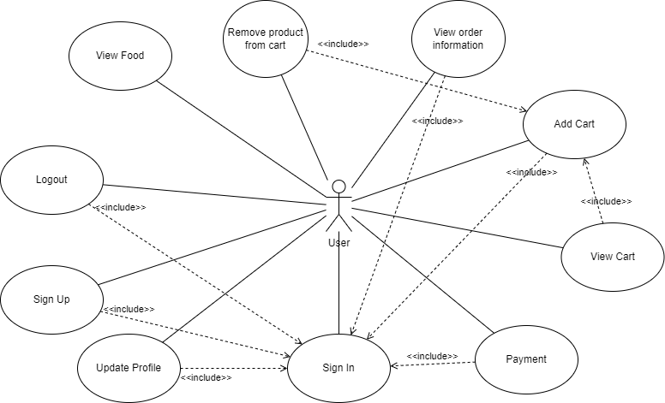

Figure 9 Use case diagram user.

In order to create a use case diagram, it is important to determine the individuals or groups of individuals, also known as actors, who will be utilizing the system. The diagram includes the actors who are expected to interact with the system. Most of the actors will be accessing the same use cases. I have identified the appropriate use cases for the 'user' actor and included them in the diagram.

The 'Sign In' use case has multiple '<<include>>' relationships because in many cases, accessing features beyond just viewing products requires the user to be authenticated and logged in. By including these relationships, the use case diagram accurately reflects the necessary steps and actions required for the user to fully utilize the system's functionality. The 'Sign In' use case acts as a gatekeeper, allows or restricts access to certain features and functionalities based on the user's authentication status. Therefore, including these relationships in the use case diagram ensures that the system is properly designed to meet the user's needs and expectations.

### Primary and Secondary Use-case scenario for User

***Primary Use-case Scenario user 1***

Table 2 Primary Use-case Scenario user 1

|  |  |
| --- | --- |
| **Use case:** | Sign in |
| **Actors:** | User |
| **Precondition:** | User has accessed the Sign-in page of the system. |
| **Flow of events:**   1. The use case starts when the user logs into the system. 2. The system displays the Sign-in page and asks the User to enter the username and password. 3. User enters username and password in the respective fields on the Sign-in page. 4. User presses " Sign-in " button. 5. The system checks the User's credentials and authenticates them. 6. If the User's Sign-in information is valid, the system allows the User to access his account and redirects the User to the main page of the system. 7. If the User's Sign-in information is not valid, the system displays an error message and asks the User to re-enter the username and password. | |
| **Postcondition:** | User has successfully logged in and accessed his account or User has failed to Sign-in and is asked to re-enter his Sign-in information. |

***Possible Secondary Scenario which could occur:***

* The user did not know their username and password.
* User does not have any account with the website.
* User forgot password.

***Primary Use-case Scenario user 2***

Table 3 Primary Use-case Scenario user 2

|  |  |
| --- | --- |
| **Use case:** | Sign up |
| **Actors:** | User |
| **Precondition:** | User has accessed the Sign-in page of the system. |
| **Flow of events:**   1. Users click on the sign in page to be able to switch to the sign-up page. 2. The system displays the sign-up page and asks the User to enter the necessary information such as name, email address, phone number, password and confirm password. 3. The user enters information in the corresponding fields on the sign-up page. 4. User presses "Sign Up" button. 5. The system checks the validity of User's sign-up information, including. 6. If the sign-up information of the User is valid, the system creates an account for the User and displays a successful registration message. 7. If the User's sign-up information is not valid, the system displays an error message and asks the User to re-enter his registration information. 8. After successful registration, User can sign into his account. | |
| **Postcondition:** | User has successfully signed-up and can Sign-in to his account or User has failed to sign-up and is asked to re-enter his registration information. |

***Possible Secondary Scenario which could occur:***

* User enters registration information and presses " Sign-up " button.
* The system checks the validity of the User's registration information.
* The system detects that the username has been used for registration before.
* The system displays an error message to the User about the username already used and asks the User to re-enter his registration information.
* User amends his registration information and presses the " Sign-up " button again.
* The system continues to check the registration information and create an account for the User if the information is valid.

***Primary Use-case Scenario user 3***

Table 4 Primary Use-case Scenario 3

|  |  |
| --- | --- |
| **Use case:** | Logout |
| **Actors:** | User |
| **Precondition:** | User has accessed the Sign-in page of the system. |
| **Flow of events:**   1. User accesses the logout page of the system. 2. The user confirms the logout request by pressing the "Log Out" button. 3. The system confirms the logout and redirects the User to the system's index page. 4. User Sign-in again if want to continue using the system. | |
| **Postcondition:** | The user has logged out of his account on the system and is redirected to the index. |

***Primary Use-case Scenario 4***

Table 5 Primary Use-case Scenario user 4

|  |  |
| --- | --- |
| **Use case:** | Cart |
| **Actors:** | User |
| **Precondition:** | User has accessed the Sign-in page of the system. |
| **Flow of events:**   1. The user has logged into the system. 2. User adds product to cart. 3. User custom increase or decrease products in the cart. 4. The user removes the product from the cart. | |
| **Postcondition:** | User successfully added, edited, and deleted in the shopping cart. |

***Primary Use-case Scenario user 5***

Table 6 Primary Use-case Scenario user 5

|  |  |
| --- | --- |
| **Use case:** | Payment |
| **Actors:** | User |
| **Precondition:** | User has accessed the Sign-in page of the system. |
| **Flow of events:**   1. The user has logged into the system. 2. User after adding products to cart and click checkout. 3. The system checks whether the product is in stock or not. 4. If the product is in stock, you will be redirected to the checkout page. 5. Users will pay via VNP. 6. After the payment is completed, the system will display the successful payment. | |
| **Postcondition:** | User successfully payment for the product |

***Primary Use-case Scenario user 6***

Table 7 Primary Use-case Scenario user 6

|  |  |
| --- | --- |
| **Use case:** | Update Profile |
| **Actors:** | User |
| **Precondition:** | User has accessed the Sign-in page of the system. |
| **Flow of events:**   1. Users access the personal information update page on the system. 2. The system displays the User's personal information. 3. Users update their personal information in the respective fields on the personal information update page. 4. The user presses the "Save" button to save the changes. 5. The system checks the validity of the newly updated information and saves the changes to the system's database. 6. The system displays a message confirming the successful update of personal information to the User. | |
| **Postcondition:** | User's personal information has been successfully updated on the system and User is notified of successful update |

### Use case Diagram for admin.

Figure 10 Use case diagram admin.

The role of an admin is crucial in managing various aspects of a website, including adding new products and categories. Additionally, an admin is responsible for managing user accounts and orders, know valuable insights into the number of subscribers and orders sold. By effectively utilizing these functions, the admin can make informed decisions to improve the website's performance and increase profitability. Therefore, it is important to have a competent and knowledgeable admin who can efficiently handle these tasks and contribute to the success of the website.

Similar to users, admins also must log in with their account to access their management page, so 'Sign In' use case has multiple '<<include>>' relationships.

### Primary and Secondary Use-case scenario for Admin

***Primary Use-case Scenario admin 1***

Table 8 Primary Use-case Scenario admin 1

|  |  |
| --- | --- |
| **Use case:** | Sign-in |
| **Actors:** | Admin |
| **Precondition:** | Admin has accessed the Sign-in page of the system. |
| **Flow of events:**   1. The use case starts when Admin Sign-in into the system. 2. The system displays the Sign-in page and asks the Admin to enter the username and password. 3. Admin enters username and password in the respective fields on the Sign-in page. 4. User presses "Sign-in" button. 5. The system checks the Admin's credentials and validates them. 6. If the Admin's Sign-in information is valid, the system allows the Admin to access his account and redirects the Admin to the system's management page. 7. If the Admin's Sign-in information is not valid, the system displays an error message and asks Sign-in to re-enter the username and password. | |
| **Postcondition:** | Admin has successfully Sign-in and accessed his account or Admin has failed to sign-in and is asked to re-enter his sign-in information. |

***Primary Use-case Scenario admin 2***

Table 9 Primary Use-case Scenario admin 2

|  |  |
| --- | --- |
| **Use case:** | Logout |
| **Actors:** | Admin |
| **Precondition:** | Admin has accessed the sign-in page of the system. |
| **Flow of events:**   1. Admin accesses the system's logout page. 2. The user confirms the logout request by pressing the "Sign Out" button. 3. The system confirms the logout and redirects the Admin to the system's index page. 4. Admin login again if you want to continue using the system. | |
| **Postcondition:** | The admin has logged out of his account on the system and is redirected to the index page. |

***Primary Use-case Scenario admin 3***

Table 10 Primary Use-case Scenario admin 3

|  |  |
| --- | --- |
| **Use case:** | Product Management |
| **Actors:** | Admin |
| **Precondition:** | Admin has accessed the Sign-in page of the system. |
| **Flow of events:**   1. Admin accesses the Product Management page on the system. 2. The system displays the data of all products in the form of a table. 3. Admin clicks on the add product button. 4. Admin accesses the Add product page and adds a new product. 5. The system confirms that the new product does not match the old product. 6. If the new product does not match the old product, the product will be added, and a success message will be displayed. 7. Admin presses the button to edit the product. 8. Admin accesses the Product Update page and edits the product. 9. The system confirms new information updated by the admin. 10. If the newly updated information from the admin does not match the existing product, the product is updated and displays a successful message. 11. Admin clicks on the button to delete the product. 12. The system displays a deletion confirmation message. 13. Admin chooses to agree to delete. 14. The product will be deleted from the database by the system. | |
| **Postcondition:** | Admin can add, edit, delete products. |

***Possible Secondary Scenario which could occur:***

* Admin add failed product.
* The system will report an error and ask the admin to re-enter the product.
* Admin does not add products but wants to return to the product management page, Admin presses Cancel button in the system.
* The system redirects to the product management page.

***Primary Use-case Scenario admin 4***

Table 11 Primary Use-case Scenario admin 4

|  |  |
| --- | --- |
| **Use case:** | Category Management |
| **Actors:** | Admin |
| **Precondition:** | Admin has accessed the Sign-in page of the system. |
| **Flow of events:**   1. Admin accesses Category Management page on the system. 2. The system displays the data of all categories in the form of a table. 3. Admin click on add category button. 4. Admin access the Add category page and add a new category. 5. The system confirms that the new category does not match the old category. 6. If the new category does not match the old category, the category will be added, and a success message will be displayed. 7. Admin presses the button to edit category. 8. Admin access category Update page and edit category. 9. The system confirms new information updated by the admin. 10. If the newly updated information from the administrator does not match the existing category, the category is updated, and a success message is displayed. 11. Admin click on delete category button. 12. The system displays a deletion confirmation message. 13. Admin chooses to agree to delete. 14. Category will be deleted from the database by the system. | |
| **Postcondition:** | Admin can add, edit, delete category. |

***Possible Secondary Scenario which could occur:***

* Admin adding category failed.
* The system will report an error and ask the administrator to re-enter the category.
* Admin has not added a category but wants to return to the category management page, Admin presses the Cancel button in the system.
* The system redirects to the category management page.

***Primary Use-case Scenario admin 5***

Table 12 Primary Use-case Scenario admin 5

|  |  |
| --- | --- |
| **Use case:** | Order Management |
| **Actors:** | Admin |
| **Precondition:** | Admin has accessed the Sign-in page of the system. |
| **Flow of events:**   1. Admin accesses the Order Management page on the system. 2. The system displays the data of the orders in the form of a table. 3. Admin selects the button to view detail order. 4. Admin access the order detail page to see how many items the order has. 5. Admin click on delete order button. 6. The system displays a confirmation message to delete. 7. Admin chooses to agree to delete. 8. The order will be deleted from the database by the system. | |
| **Postcondition:** | Admin can delete and view detail orders. |

***Primary Use-case Scenario admin 6***

Table 13 Primary Use-case Scenario admin 6

|  |  |
| --- | --- |
| **Use case:** | Customer Management |
| **Actors:** | Admin |
| **Precondition:** | Admin has accessed the Sign-in page of the system. |
| **Flow of events:**   1. Admin accesses Customer Management page on the system. 2. The system displays customer data in the form of a table. 3. Admin click on delete customer button. 4. The system displays a confirmation message to delete. 5. Admin chooses to agree to delete. 6. Customer will be deleted from the database by the system. | |
| **Postcondition:** | Admin can delete customer. |

## Entity Relationship Diagrams

Figure 11 Entity Relationship Diagrams

In the Entity Relationship Diagram (ERD) shown in **Figure 11**, there are several entities including Customer, Admin, Product, Order, Order Detail, and Category. Each entity has its own set of attributes, such as the Customer entity having attributes like name, gender, address, phone number, email, date of birth, username, password, and date of creation. The admin entity has attributes like account, password, and full name. The Product entity has attributes like product name, product type, price, image, status, and description, and so on for the other entities.

The relationships between entities are indicated by the arrows connecting them. For example, there is a "many-to-one" relationship between the Order and the Customer entities, meaning a customer can have multiple orders but each order can only have one customer. Similarly, the Order Detail entity has a "many-to-many" relationship with the Product entity, meaning each detail order can have multiple products and each product can be placed in multiple detail orders.

Overall, the ERD provides a visual representation of the entities, attributes, and relationships in the system being modelled, helping to better understand the structure and interactions of the data in the system.

## Wireframes for prototypes

### Wireframes for user

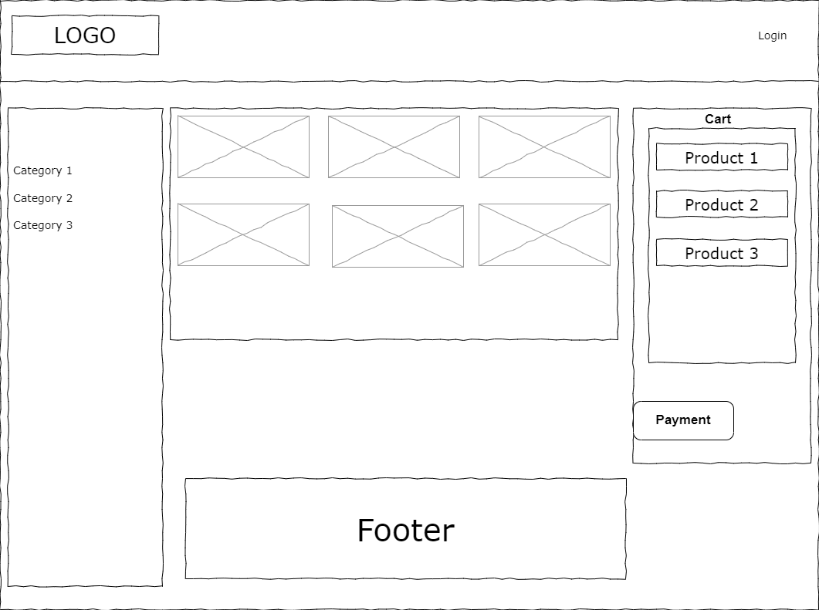

Figure 12 Home Page

**Figure 12** shows on the header there will be a logo and a Login button. The login button can be used to login/logout from the site. Clicking on the Logo will bring the user back to the homepage. In the middle is a section containing information about the website including products and product types. On the right side is the website shopping cart. Below is the footer of the website.

Figure 13 Sign in Page

**Figure 13** shows the sign in page of the website. Here users can sign in with an account to be able to purchase. To be able to sign in, everyone needs to register an account on the Sign-up page in **Figure 14**.

Figure 14 Sign-up page

**Figure 14** shows the sign-up page of the website. Here users need to fill in all information to be able to sign up as a member of the website.

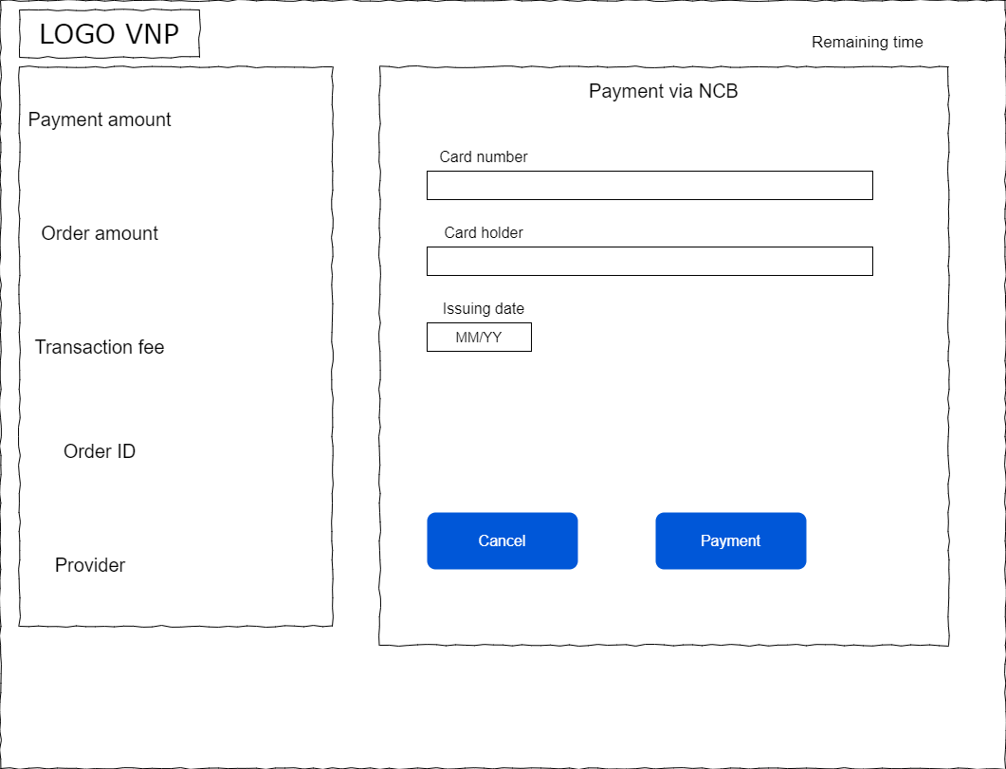

Figure 15 Payment Page

**Figure 15** shows the website's Payment page. Here, users will pay with a bank card to buy products at the website.

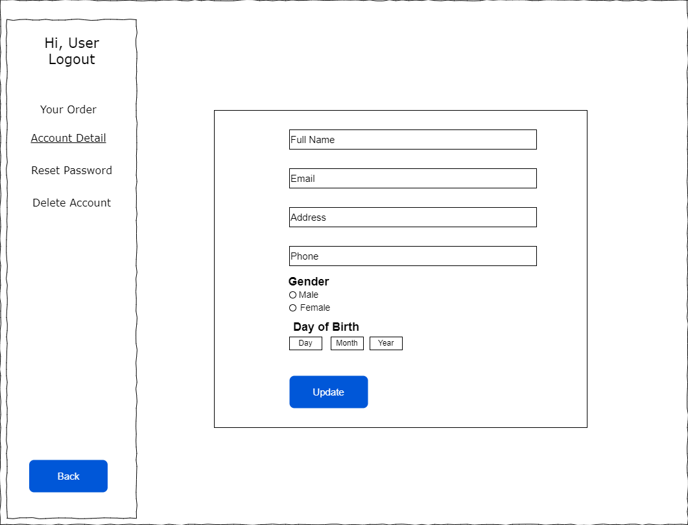

Figure 16 Account Detail

**Figure 16** shows the account update page for the user, where there are fields to fill in personal information for the user to update information and add missing information.

Figure 17 Reset Password

**Figure 17** shows the site's password reset page, where users can update their passwords.

Figure 18 Your Order

**Figure 18** shows your order page of the website, where users will review their orders placed. There are also buttons here so that when the user receives the goods, they will click to indicate that the goods have been received.

### Wireframes for admin

On the admin page, there are a total of 5 management pages, and each page will depend on the data to be managed and have its own add, edit, and delete functions. Because of that, the admin management pages have almost the same pages and lead to the same wireframes. Since the admin dashboards have similar wireframes, I'll just symbolize the wireframes that I feel are different from the rest of the wireframes. The official pages will be taken by me and explained in section **9.5** of the report.

Figure 19 Dashboard

**Figure 19** shows the site's admin dashboard. Here will display the revenue statistics, in addition to the order and user statistics of the website. Here, it is also possible to track new users and recently placed orders.

Figure 20 Product Management

This is the main Wireframe of the system's product management page and other management pages, such as Category, Customer, and Order, can be seen in **Figure 20**. The wireframe includes buttons to add, edit, and delete items. The add button is conveniently located on the board to allow for easy addition of new products or categories but is not present in sections such as order or customer. The edit column in the table contains two buttons, delete, and edit, which allow the administrator to delete or modify data as needed. Additionally, a search bar is available on each page to help the admin quickly find data when dealing with large amounts of information.

Figure 21 Add Product

**Figure 21** shows the product add a page, which serves as the main wireframe for the add and edit pages. It is noteworthy that the edit page shares the same layout as the add page and only displays the data of the selected product. Additionally, the edit function is only available for product and category management pages, but not for other pages such as customer and order. The add page enables the admin to input the product information, select an appropriate image and add the product to the system. The cancel button is provided if the admin decides not to proceed with the addition.

## Activity Diagram

### Activity Diagram for user

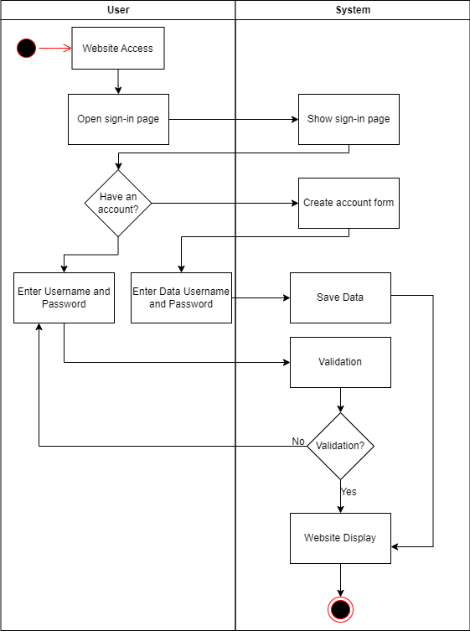

Figure 22 Activity diagram sign in user

**Figure 22** shows the operation diagram of the sign-in function. When the user sign-in. If they don't have an account, they will select the "Create an account" option and enter personal information into the website. After entering all the information, the website will show the user that the account has been created.

If the user already has an account, they will enter their username and password into the website. If this information is incorrect, the site will ask the user to sign-in again. If the sign-in information is correct, the website will show the user the features and functionality of the website.

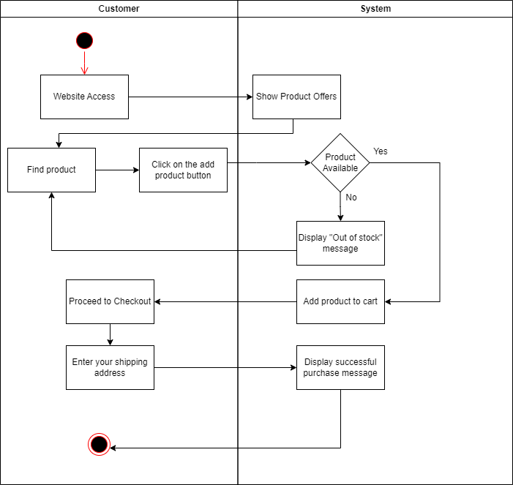

Figure 23 Activity diagram add to cart.

**Figure 23** shows the working diagram of the add products to cart function. An activity diagram depicts the flow of activity when a user visits a website to purchase a product. When users enter the site, they are shown the products that are being sold on the site. They then search for the product they want to buy and click the "Add product to cart" button.

If the product is out of stock, the website will display the message "Out of stock" and ask the user to search for another product. If the product is still in stock, the site will add the product to the user's cart. The user can then continue shopping or proceed to checkout.

If the user wants to pay, they select "Proceed to checkout" and enter their shipping address. After entering all the information, the website will display a successful purchase notification and the user will receive his product at the provided address.

### Activity Diagram for admin

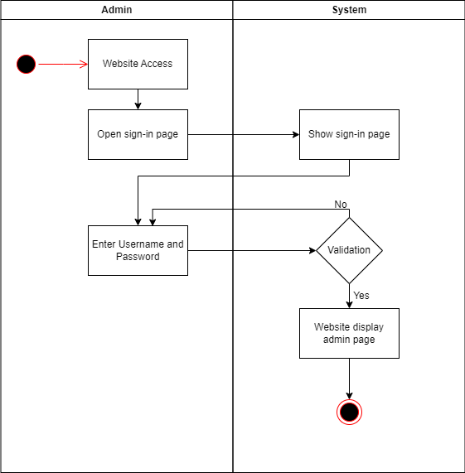

Figure Activity diagram sign-in admin

**Figure 24** shows the operation diagram of the sign-in function by admin. When the admin logs in, enter the admin's username and password into the website. If this information is incorrect, the site will ask the admin to login again. If the login information is correct, the site will show the admin to the site's admin page to proceed with the management.

Figure 25 Activity diagram add new product.

**Figure 25** shows the working diagram of the add product function. During this process, the admin accesses the site after signing in. Then, select "Manage Products" to access the product management page and click the "Add New Product" button. The website will display a form where the user can fill in the information of the new product and upload the product image. After the user fills in the product information and uploads the image, the website checks the product information to make sure that the fields have been entered correctly. If the product information is invalid, the website will display an error message and ask the user to modify the product information. If the product information is valid, the website will save the new product in the database and display a success message to inform the user that the product has been added successfully.

Figure 26 Activity diagram search

**Figure 26** shows the working diagram of the search function. Admin enters the search keyword into the website. If there are results, the site will display search results related to that keyword and the admin can select a result from the list and click on it to view and edit. If there are no search results, the system will notify you that there are no products that the admin is looking for. If the admin wants to search with another keyword, they can go back to the search bar and enter a new keyword.

# Implementation

## Database

## Front End

## Back End

Structure Application

Controller / Views / Database …

## Deployment

## Images

# Testing

# Evaluation

## Summarised Key findings from the project.

## Recommendations for future development

## Project Evaluation

## Personal Evaluation

## Conclusion

### What went well?

### What did not go well?

### What have I learned from this project?

### Future development

# References

# Appendix A – Project Proposal

# Appendix B

# Appendix C

1. https://kfcvietnam.com.vn/kfc-tabs/our-story
2. https://thietkethuonghieu.mondial.vn/tin-tuc/kham-pha-thuong-hieu-kfc-news-80.html
3. https://mcdonalds.vn/gioi-thieu-mcdonalds
4. https://phuongnamdigital.com/vi/tin-tuc/mcdonalds-that-bai-tai-viet-nam.html
5. https://p92.com/techdetails/html-css-and-javascript
6. https://techhubsolutions.in/php-with-mysql/
7. https://tudip.com/blog-post/heroku/
8. https://dbdb.io/db/cleardb